LAB EXPERIMENT 3
Database Schema for a customer-sale scenario
Customer(Cust id : integer, cust_name: string)
Item(item_id: integer, item_name: string, price: integer)
Sale(bill_no:integer,bill_data:date,cust_id: integer, item_id: integer, qty_sold: integer)
For the above schema, perform the following—
- Create the tables with the appropriate integrity constraints.
QUERY:
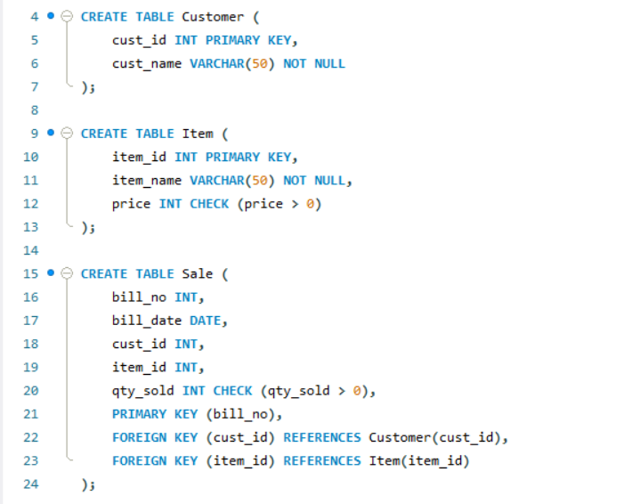

- Insert around 10 records in each of the tables.
QUERY:
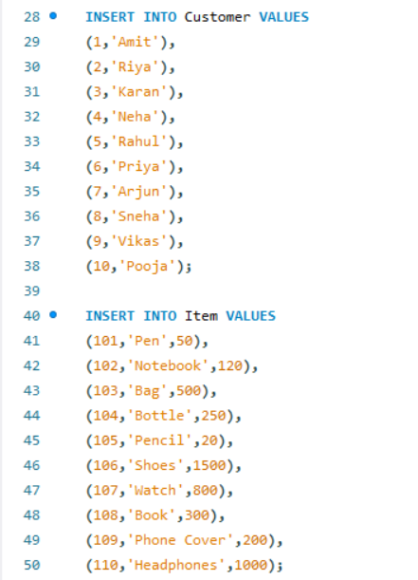
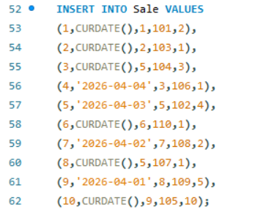

- List all the bills for the current date with the customer names and item numbers.
QUERY:
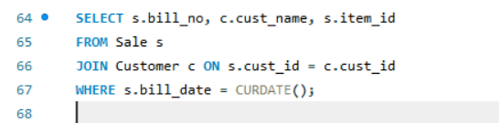
OUTPUT:
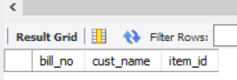
- List the total Bill details with the quantity sold, price of the item and the final amount.
QUERY:
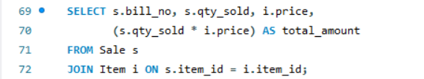
OUTPUT:
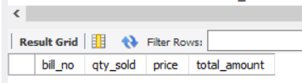

- List the details of the customer who have bought a product which has a price>200.
QUERY
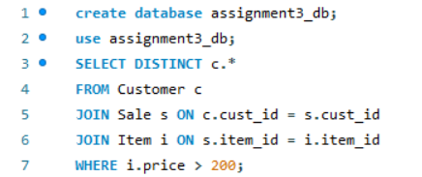
OUTPUT:
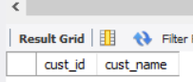
- Give a count of how many products have been bought by each customer
QUERY:
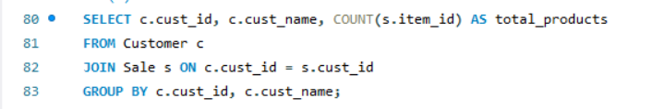
- Give a list of products bought by a customer having cust_id as 5.
QUERY:
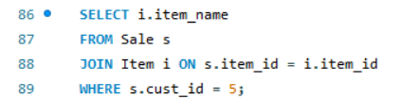

- List the item details which are sold as of today.
QUERY:
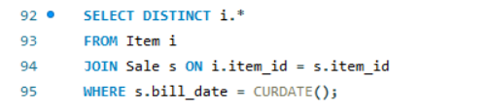
- Create a view which lists out the bill_no, bill_date, cust_id, item_id, price, qty_sold, amount.
QUERY:
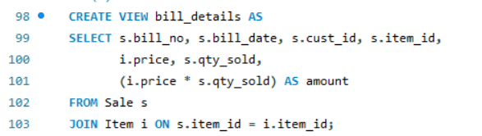
10. Create a view which lists the daily sales date wise for the last one week
QUERY:
